Tugas LK-04 Pemrograman Web

Nama : Zayyan Muhammad
NIM : 241020039
Kelas : B
Link Repository GitHub
https://github.com/Zayy09/lk04
Link Website (GitHub Pages)
https://zayy09.github.io/lk04/

  - Tampilan Desktop
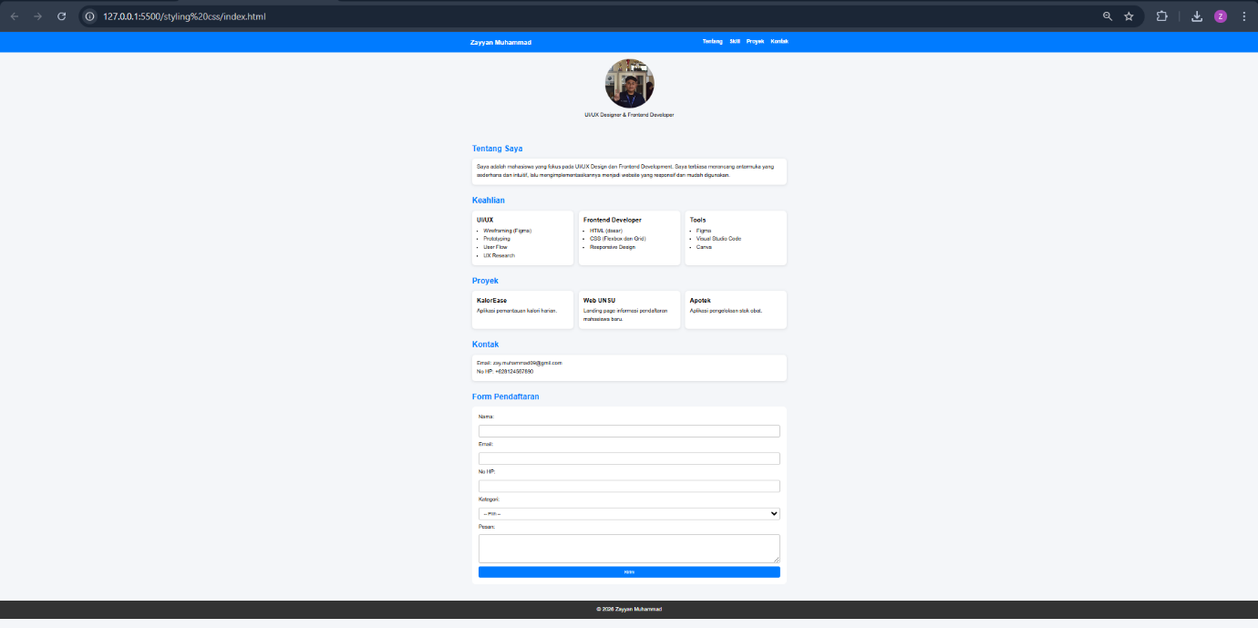

  - Tampilan Mobile
